
Year 10 Homework – Autumn Term 1

For your science homework, we expect ONE HOUR per week on:
 | Go to https://www.century.tech/  Click on account login  Sign in with Office 365 (your school username and password)  Complete the set activities in your path
AND
For each video create either:
1) Flash cards
2) Posters
3) Quizzes
4) Hand written notes

Atomic Structure – 2nd September   | Atomic Structure – 9th September  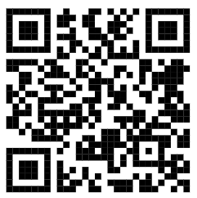 | Atomic Structure – 16th September   | Atomic Structure – 23rd September  
Atomic Structure – 30th September  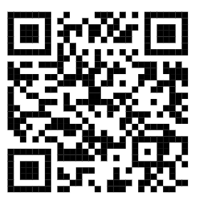 | Energy -7th October   | Energy -14th October   | Energy – 21st October  

IF YOU DO BOTH YOU WILL HAVE GOLD BY YOUR NAME, FOR ONE IT IS GREEN. OTHERWISE IT IS AMBER OR RED.

