
Year 10 Homework – Autumn Term 1
For your science homework, we expect ONE HOUR per week on:
 | Go to https://www.century.tech/  Click on account login  Sign in with Office 365 (your school username and password)  Complete the set activities in your path
AND

For each video create either:
1) Flash cards
2) Posters
3) Quizzes
4) Hand written notes

Atomic Structure – 2nd September   | Organisation – 9th September   | Atomic Structure – 16th September  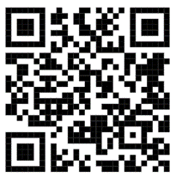 | Organisation – 23rd September  
Atomic Structure – 30th September   | Organisation-7th October  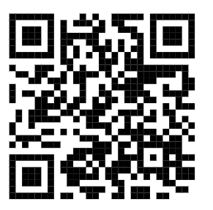 | Atomic Structure -14th October   | Organisation– 21st October  

IF YOU DO BOTH YOU WILL HAVE GOLD BY YOUR NAME, FOR ONE IT IS GREEN. OTHERWISE IT IS AMBER OR RED.

