
Year 11 Homework – Autumn Term 1
For your science homework, we expect ONE HOUR per week on:
 | Go to https://www.century.tech/  Click on account login  Sign in with Office 365 (your school username and password)  Complete the set activities in your path
AND

For each video create either:
1) Flash cards
2) Posters
3) Quizzes
4) Hand written notes

Forces – 2nd September  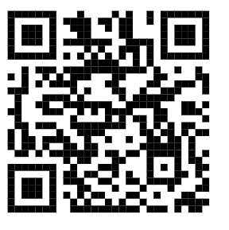 | Forces – 9th September   | Forces – 16th September   | Forces – 23rd September  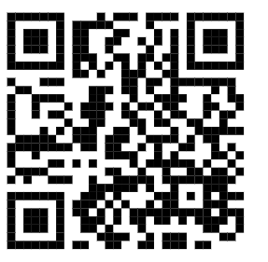
Homeostasis – 30th September  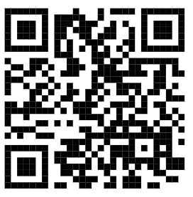 | Homeostasis -7th October  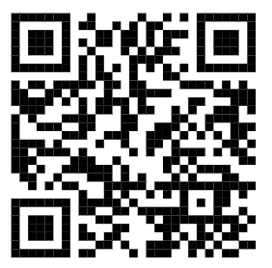 | Homeostasis -14th October  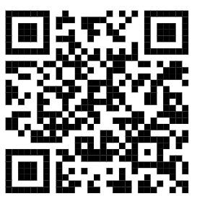 | Rates of Reaction – 21st October  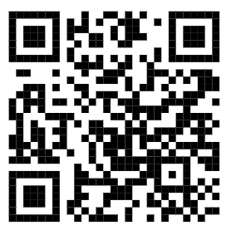

IF YOU DO BOTH YOU WILL HAVE GOLD BY YOUR NAME, FOR ONE IT IS GREEN. OTHERWISE IT IS AMBER OR RED.

